EXPERIMENT NO. 4
Implement Loops and Arrays

PART B – TO BE COMPLETED BY STUDENTS
Roll No. C-60
Name Avdhut Parish Madhavi
Class / Division SE-C
Batch C2
Date of Experiment ________________________________________________
Date of Submission ________________________________________________
Grade ________________________________________________

B.1 Document Created by the Student
Create an array with at least five values, calculate a required summary, and paste the output.
public class VitalArrayDemo {
public static void main(String[] args) {
int[] pulse = {72, 75, 70, 78, 74};
int total = 0;

System.out.println("Pulse readings:");
for (int i = 0; i < pulse.length; i++) {
System.out.println("Reading " + (i + 1) + ": " + pulse[i]);
total += pulse[i];
}

double average = (double) total / pulse.length;
System.out.println("Average = " + average);

System.out.println("Using enhanced for loop:");
for (int value : pulse) {
System.out.print(value + " ");
}
System.out.println();

int i = 0;
while (i < pulse.length) {
if (pulse[i] > 75) {
System.out.println("Reading above 75: " + pulse[i]);
}
i++;
}

int[][] ward = {
{101, 102},
{201, 202}
};

System.out.println("Ward matrix:");
for (int r = 0; r < ward.length; r++) {
for (int c = 0; c < ward[r].length; c++) {
System.out.print(ward[r][c] + " ");
}
System.out.println();
}
}
}

Output:
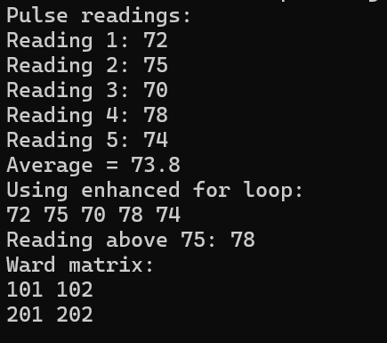

B.2 Student Program / Output
Paste/write the final program and attach or reproduce the observed output below.
Java Program
public class VitalArrayDemo {
public static void main(String[] args) {
int[] pulse = {65, 70, 75, 80, 85};
int total = 0;

System.out.println("Pulse readings:");

for (int i = 0; i < pulse.length; i++) {
System.out.println("Reading " + (i + 1) + ": " + pulse[i]);
total += pulse[i];
}

double average = (double) total / pulse.length;
System.out.println("Sum = " + total);
System.out.println("Average = " + average);

System.out.println("Using enhanced for loop:");
for (int value : pulse) {
System.out.print(value + " ");
}
System.out.println();

int i = 0;
while (i < pulse.length) {
if (pulse[i] > 75) {
System.out.println("Reading above 75: " + pulse[i]);
}
i++;
}

int[][] ward = {
{101, 102},
{201, 202}
};

System.out.println("Ward matrix:");
for (int r = 0; r < ward.length; r++) {
for (int c = 0; c < ward[r].length; c++) {
System.out.print(ward[r][c] + " ");
}
System.out.println();
}
}
}

Output:
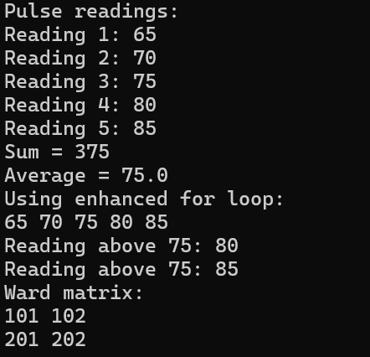

B.3 Observations and Learning
- Why does array indexing begin at zero?
Array indexing begins at zero because the first element is located at an offset of zero from the starting position of the array.

- What exception may occur when an invalid array index is used?
Java throws an ArrayIndexOutOfBoundsException when an invalid index is used to access an array element.

- When is a two-dimensional array useful?
A two-dimensional array is useful for storing data in rows and columns, such as matrices, tables, and seating arrangements.

Student observation / learning:
The program demonstrates the use of one-dimensional and two-dimensional arrays. The for loop displays array elements and calculates their sum, while the enhanced for loop traverses the array. The while loop identifies readings above 75, and nested loops display the two-dimensional ward array.

B.4 Conclusion
Values are illustrative programming data rather than clinical thresholds.
Student conclusion:
The experiment demonstrated the use of loops and arrays in Java. The program successfully displayed array elements, calculated their sum and average, identified values above a specified limit, and displayed a two-dimensional array.

B.5 Questions of Curiosity
- Why does Java array indexing start at zero?
Java array indexing starts at zero because the first element has an offset of zero from the beginning of the array.

- What exception can occur for an invalid array index?
An ArrayIndexOutOfBoundsException occurs when a program tries to access an array element using an index outside the valid range.

- When would a multidimensional array be useful?
A multidimensional array is useful when data must be organized into multiple dimensions, such as rows and columns in a matrix or a table of student marks.

